**Advance Excel Assignment 1**

Question 1: What do you mean by cells in an excel sheet?

Solution 1: A cell is an essential part of MS-Excel. It is an object of Excel worksheets. Whenever you open Excel, the Excel worksheet contains cell to store the information in them. You enter content and your data into these cells. Cells are the building blocks of the Excel worksheet. You can check the below in which rectangular boxes are cells in excel sheet.



Question 2: How can you restrict someone from copying a cell from your worksheet?

Solution 2: First go to excel ribbon tab and select Review tab and click on Protect Sheet and enter password and after entering the password you can restrict someone from copying a cell.

Question 3: How to move or copy the worksheet into another workbook?

Solution 3: To move or copy the worksheet into another workbook follow the below steps.

i ] Right click on the tab and select Move or Copy from the context menu. This will open the Move or Copy dialog box.

ii ] Under Before sheet, choose where you want to place the copy.

iii ] Put a tick in the Create a copy box.

iv ] Click OK.

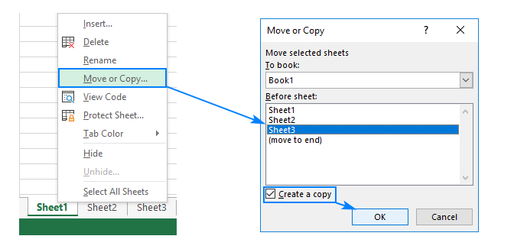

Question 4: Which key is used as a shortcut for opening a new window document?

Solution 4: Select an existing word document and click Ctrl + N and this will open new word document.

Question 5: What are the things that we can notice after opening the Excel interface?

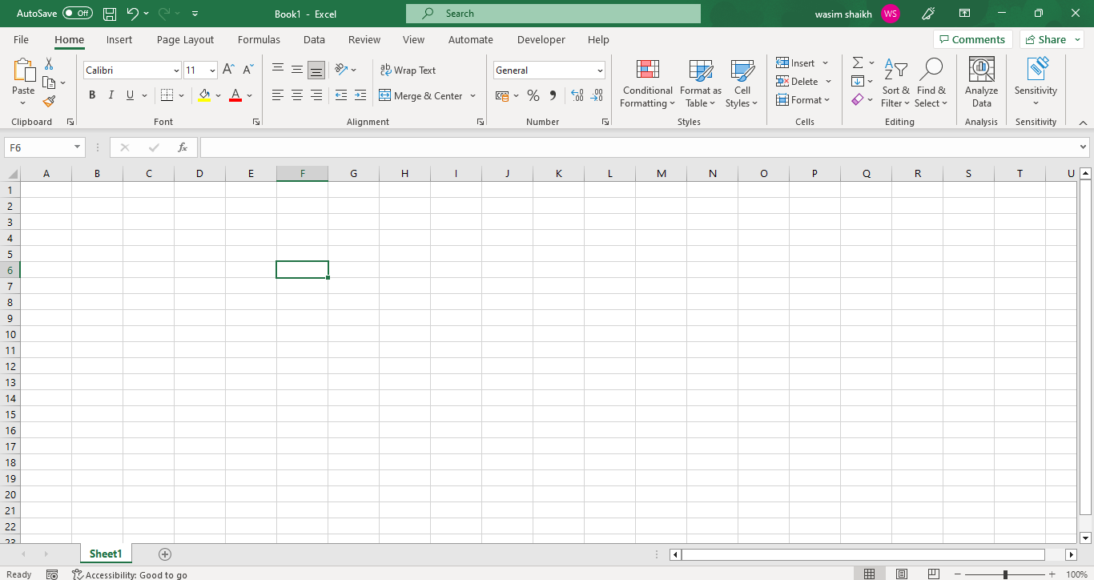

Solution 5: After opening the excel interface we can notice the Ribbon tab which consists of File, Home, Insert, Page Layout, Formulas, Data, Review, View, Automate, Developer and Help. We can also sheet1 and the cells inside all the sheet1 and you can see the save button and also AutoSave button which you can toggle on or off as per your requirements.

Question 6: When to use a relative cell reference in excel?

Relative cell reference is a type of cell reference in Excel. This reference changes when the formula is copied to any other cell or any other worksheet. Relative cell references are used whenever calculations need to be repeated.